**First Floor**

First Floor – front room

First Floor – middle room

First Floor – Sunroom

First Floor – Room beside kitchen

First Floor - Kitchen

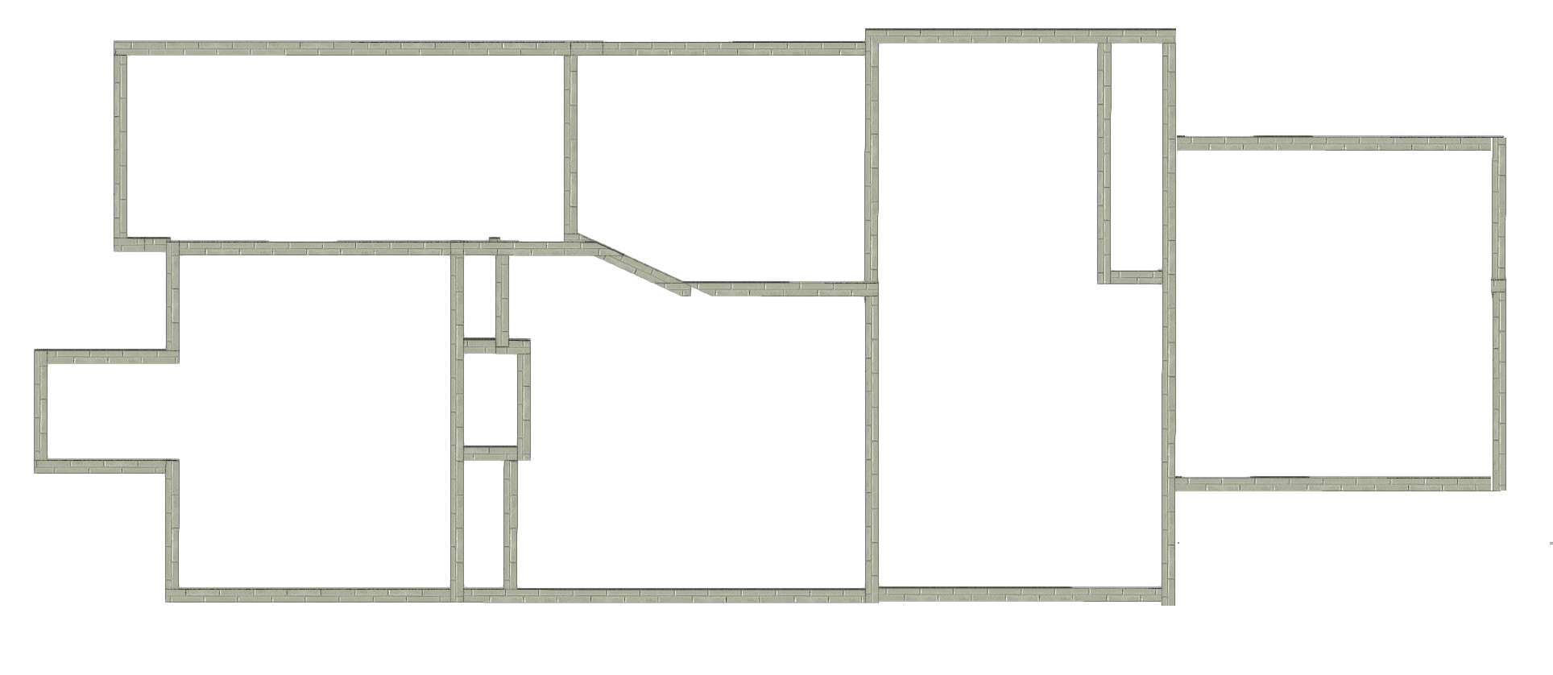

**Second Floor**

2nd Floor – Blue Rm

2nd Floor – Middle Rm

****

2nd Floor – Middle Rm

2nd Floor – Back Hallway

2nd Floor – Back Room/Carpeted